
Story

Date | 26 July 2026
Team ID | MIRUTHALA M K
Project Name | Global AI Adoption in Education
Maximum Marks | 5 Marks

Activity 1: Story Design:
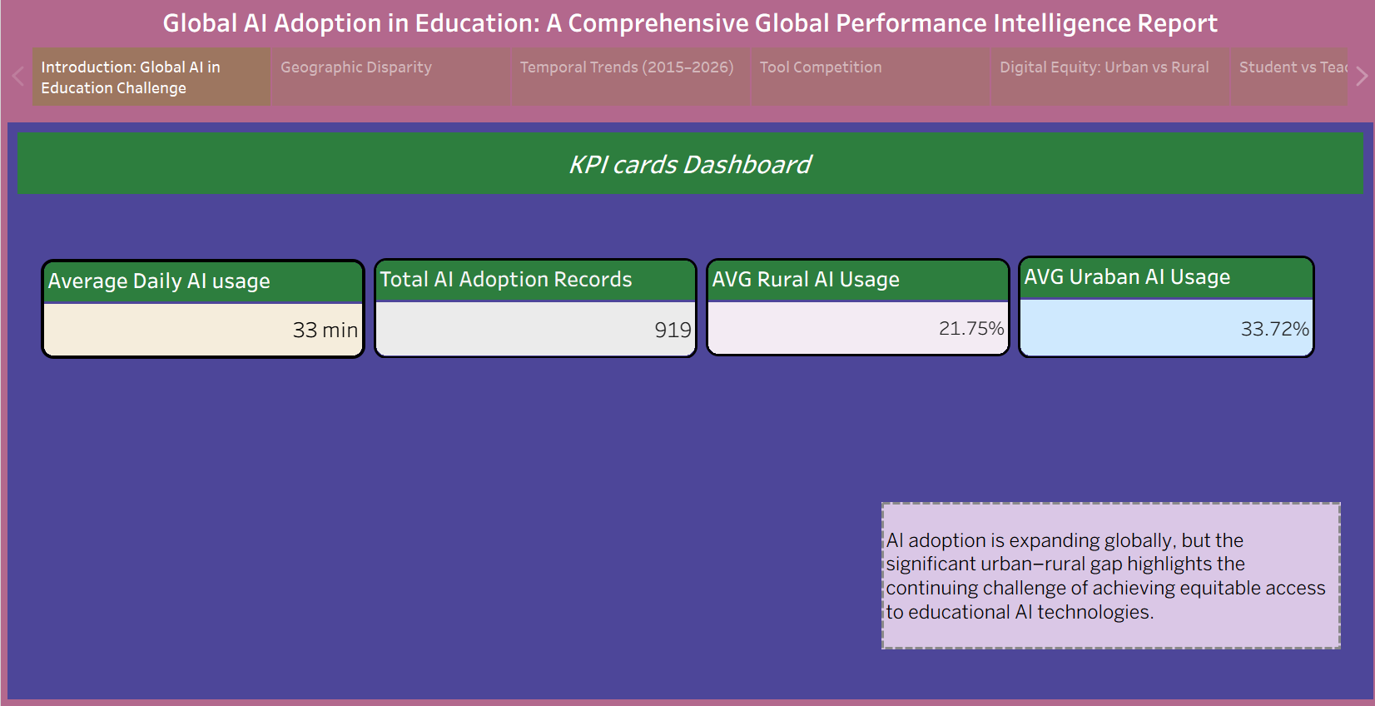

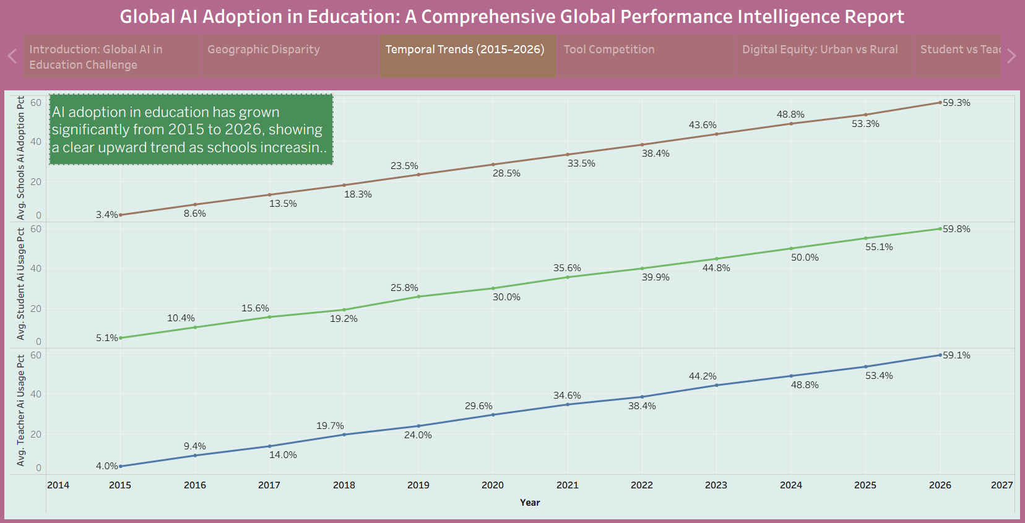
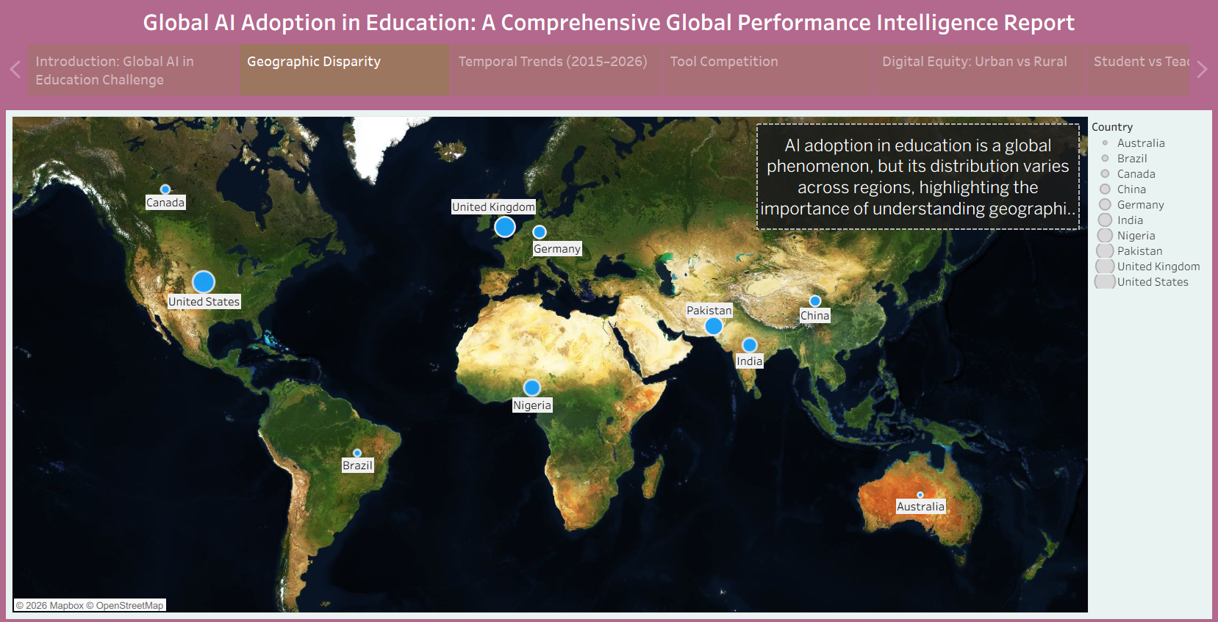

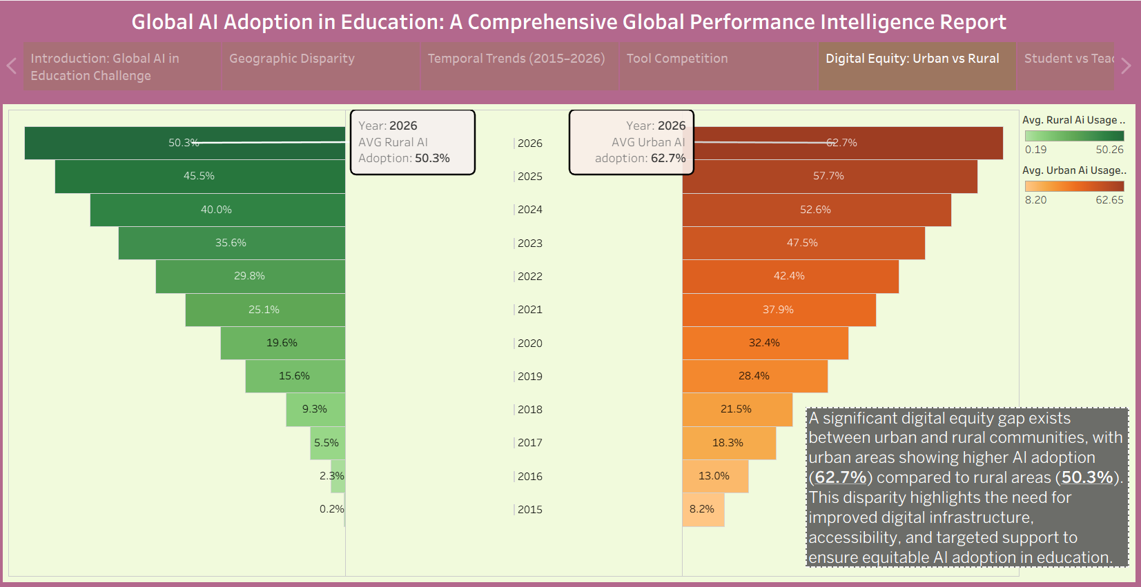
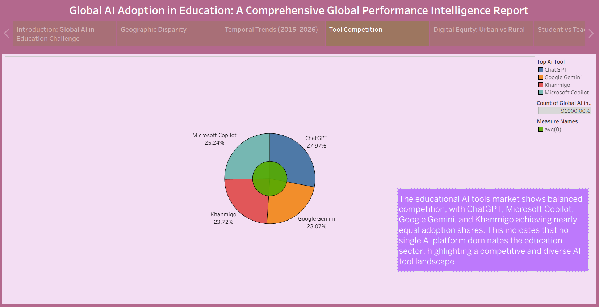

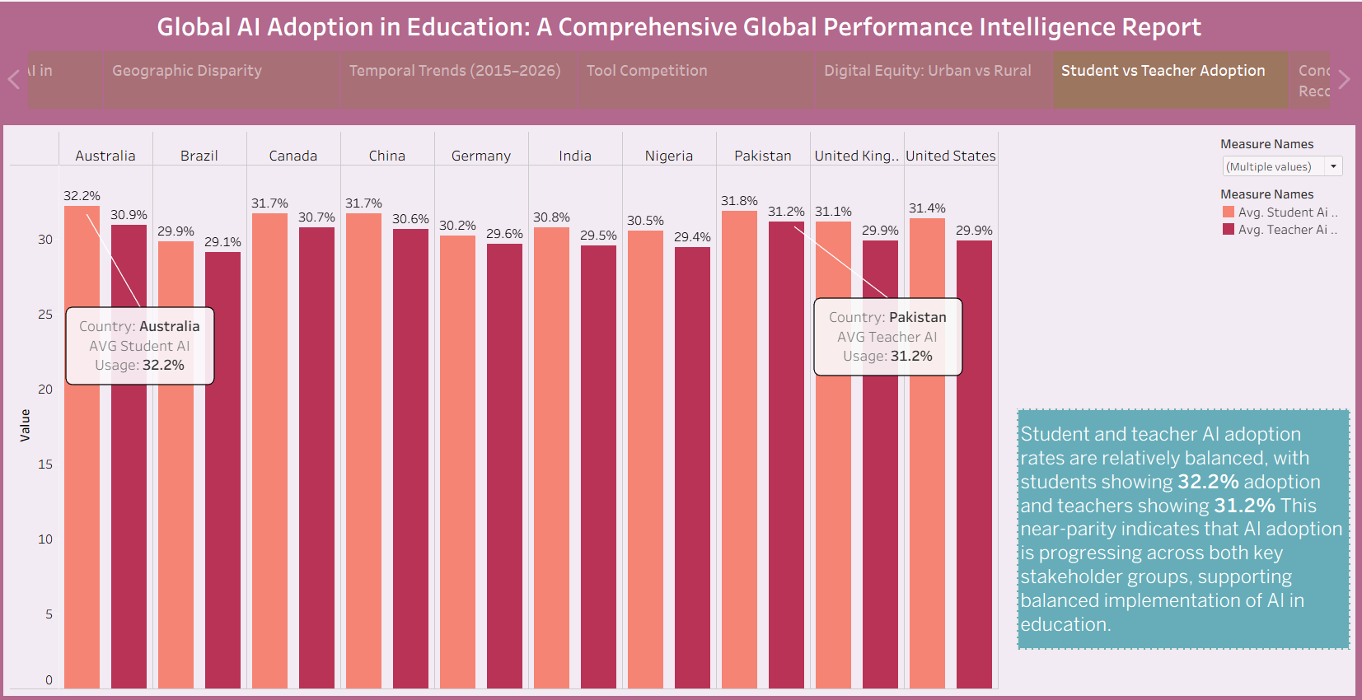
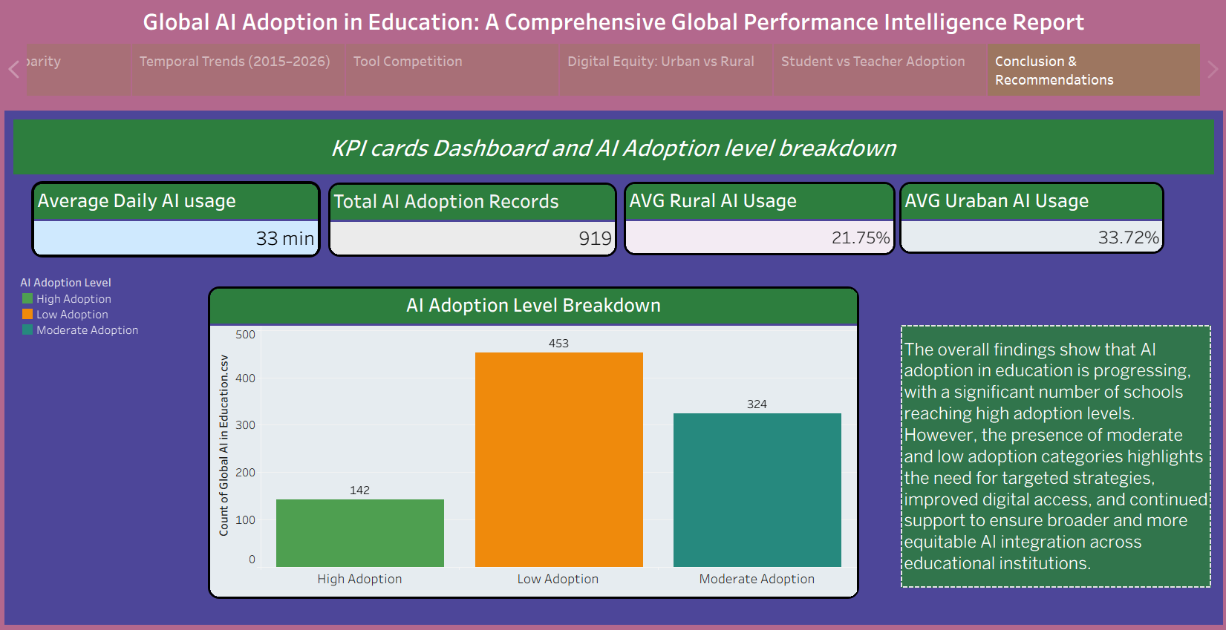

Tableau Story Narrative & Observations
- By leveraging the sequential story point structure in Tableau, the Global AI Adoption in Education analytical presentation guides users through a logical progression of AI adoption metrics, transforming structured education data into a cohesive global AI adoption narrative.
- Based on the interactive visualizations and dashboard analysis, the core observations are:
- · Significant Growth in AI Adoption Over Time: The trend analysis from 2015 to 2026 shows a clear increase in AI adoption across students, teachers, and schools. School AI adoption increased from approximately 5.1% in 2015 to 59.8% in 2026, highlighting the rapid integration of AI into education.
- · Urban AI Usage is Higher Than Rural AI Usage: The dashboard shows a clear difference between rural and urban AI usage. Average rural AI usage is 21.75%, while average urban AI usage is 33.72%, highlighting a significant difference in AI adoption between the two communities.
- · Student AI Usage is Slightly Higher Than Teacher AI Usage: The student-versus-teacher comparison shows that student AI usage is slightly higher than teacher AI usage in most countries. This indicates differences in the way AI tools are adopted by learners and educators.
- · Country-Level Differences in Daily AI Usage: The country comparison visualization shows differences in average daily AI usage across countries. Canada shows the highest average daily AI usage among the displayed countries at approximately 37.6 minutes, allowing users to compare AI usage patterns globally.
- · ChatGPT Leads the AI Tool Market Share: The AI tool comparison shows that ChatGPT has the highest market share at 27.97%, followed by Microsoft Copilot, Khanmigo, and Google Gemini. This highlights the popularity of different AI tools in the education sector.
- · Low and Moderate AI Adoption Remain Significant: The adoption-level analysis shows 453 records under Low Adoption, 324 records under Moderate Adoption, and 142 records under High Adoption. This indicates that a considerable number of records still fall under low and moderate AI adoption categories.
- · Regional Differences in School AI Adoption: The regional comparison shows variations in school AI adoption. Oceania has the highest school AI adoption at 31.07%, while South America has the lowest among the displayed regions at 28.42%.
- Overall, the Tableau story presents a progressive narrative that begins with a global overview of AI adoption, moves through country and user-group comparisons, examines the growth of AI adoption over time, and concludes with rural-urban, AI tool, adoption-level, and regional analysis.

Activity 2:
Publish Story on Tableau Public and Paste Public link below
https://public.tableau.com/app/profile/miruthala.m.k/viz/GlobalAIinEducationStory/GlobalAIAdoptioninEducationAComprehensiveGlobalPerformanceIntelligenceReport?publish=yes

Web Deployment URL
https://ai-adoption-in-education-miruthala-mk.netlify.app/

